**Principles of pasture growth**

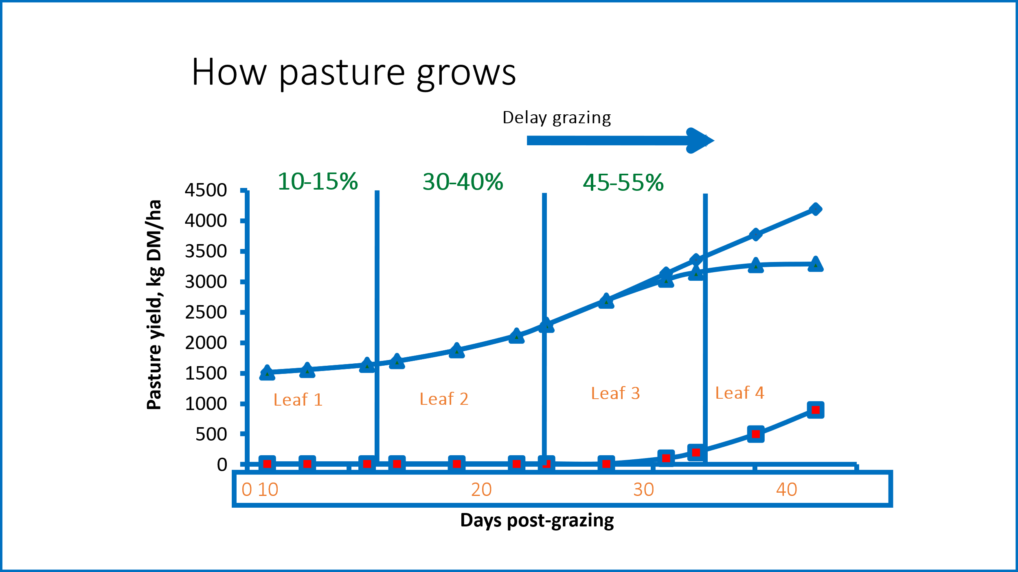

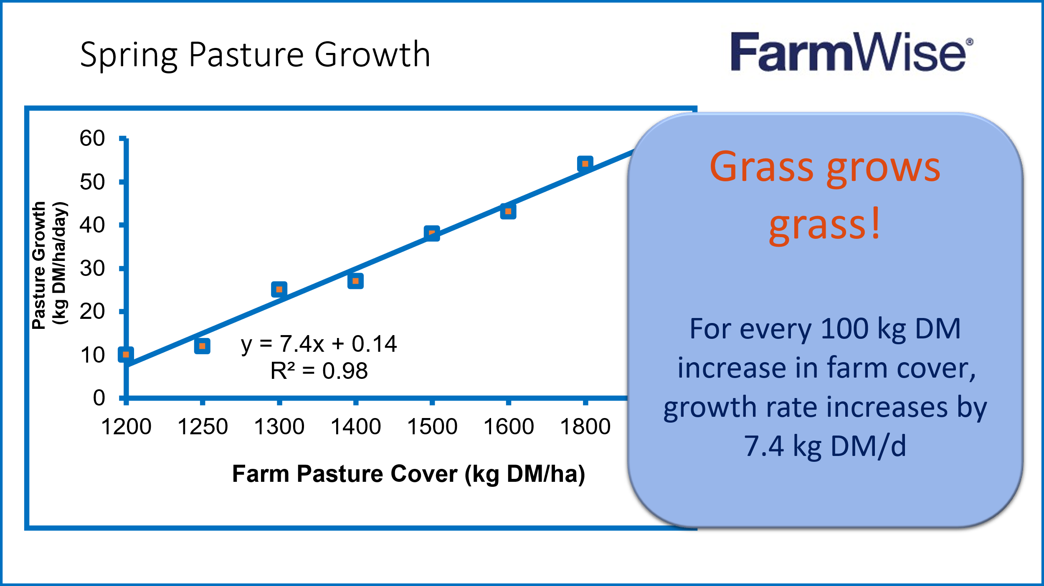

**Grass Grows Grass!**

**Quality matters**

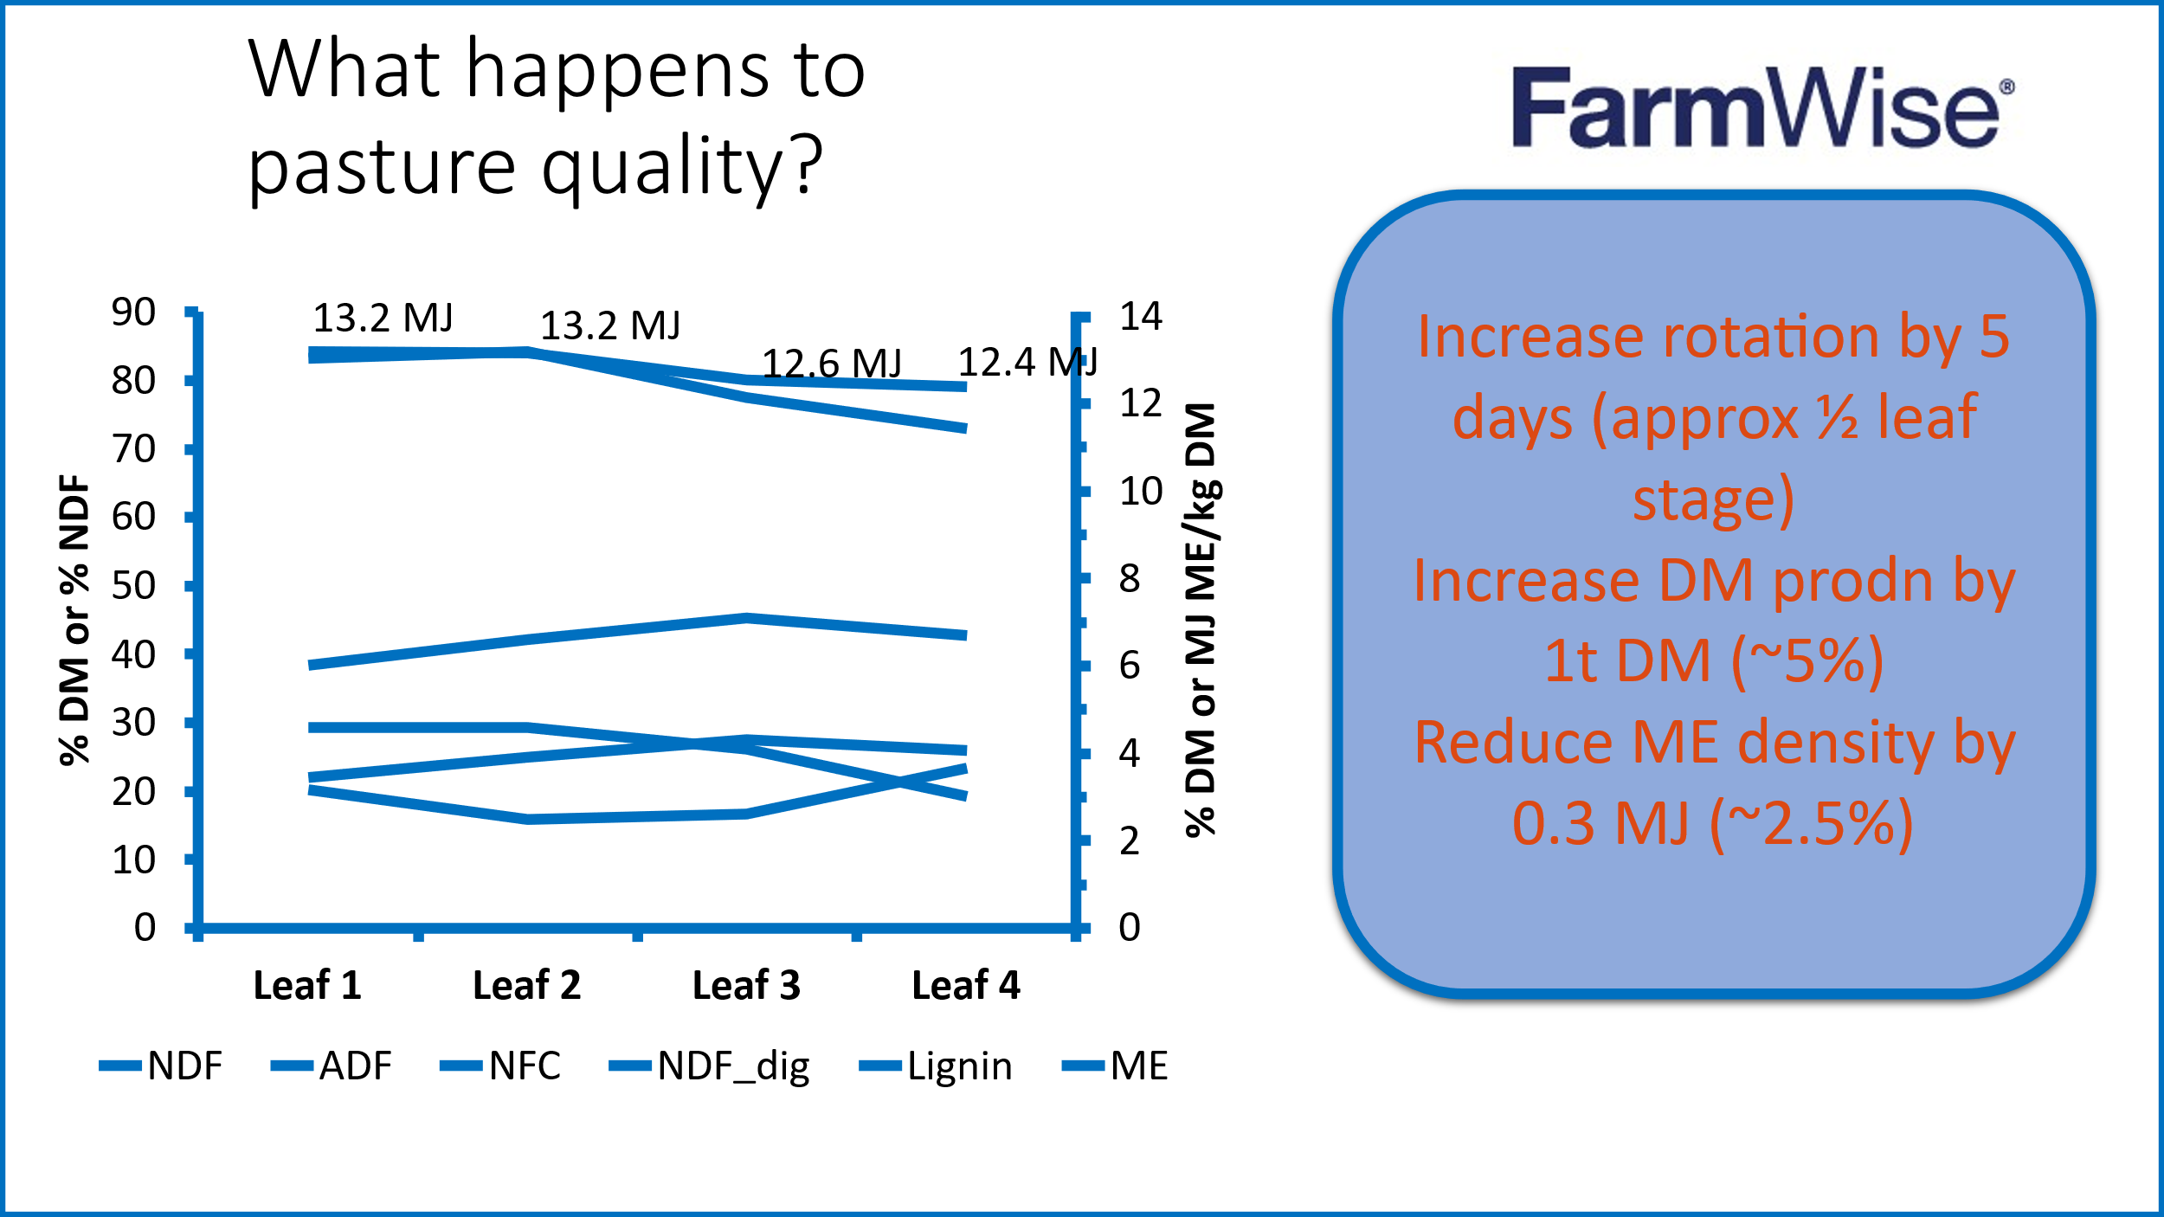

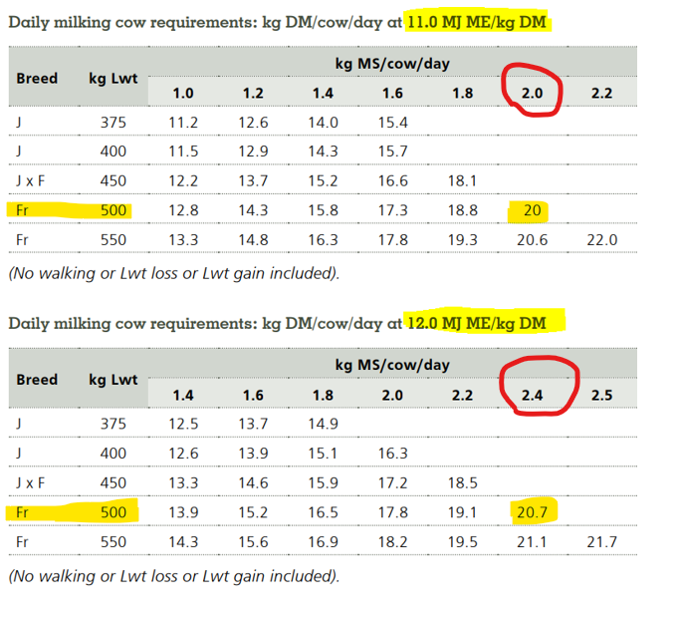

**Setting trigger points and using farm walk data**

|  |  |  |
| --- | --- | --- |
| **Pre-grazing cover target** | (stocking rate **x** intake **x** round length) **+** residual | = |
| **Round length** | (pre-grazing cover **–** residual) / stocking rate / intake | = |

**Leo’s advice:**

* Set up round length according to pre-grazing cover target above 2½ to 3rd leaf stage (3000+)
* Target a residual to your system
* Use mower proactively
* Your pre-grazing cover target is your trigger point
  + Paddocks above target get stepped over for silage
  + If covers are below target, then feed supplements (don’t speed up round)

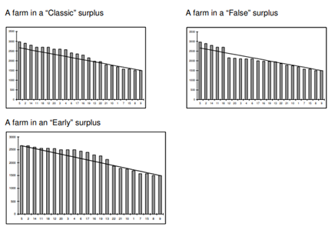

|  |
| --- |
| **Rules for mowing**   * + - **Start mowing as soon as growth exceeds demand**   **(stocking Rate * grass intake/cow)**   * + - **If mowing in front of cows, you need to allow for 100 kgDM/ha extra cover on paddocks**     - **Mow night breaks after morning milking (no more than 50%-60% of area grazed daily)**     - **Graze night and day paddocks so mower goes over whole paddock**     - **Follow mower with urea at 65 kg/ha**   **Mowing on front or behind?**   * + - **Mowing on front**        * **Potentially increases intakes**       * **Creates wilting, increases palatability and harvesting efficiency, but doesn’t improve the quality!**       * **Takes the selection away from cows, so quality of the intake will be down**       * **A soon as you see brown clumps behind the mower (ranked grass), it means that you’re better off topping behind cows**     - **Topping**       * **Allows for cows to select what they eat**       * **For some reason milk solid % goes up as well as production**       * **Dungs get spread over paddock (and tractor ☹)** |