**SDH October growth rate and pasture quality summary (to 2 April)**

After earlier predictions of a dry summer for the region we have continued to grow above demand through February and March. Growth rates between standard and lower impact farmlets have deviated through the summer months, with the LI farmlets growing approximately 10 kg DM/ha/day less than the standard farmlets. This difference in growth reflects the difference in N fertiliser strategy between the farmlets. Season to date the Std farmlets have received 155-180 kg N/ha compared with only 46-50 kg N/ha for the LI farmlets.

We are just commencing the 10th round of grazing for some paddocks. On the pasture quality front the DM% in the pastures has dropped from to around 19% at peak to only 12-14.5% in March/April (Table 2). Despite the lower N fertiliser applications on the LI farmlets, average pasture crude protein in March was 27%, compared to only 25% for the Std farmlets. This high crude protein content is attributed to the higher clover content in the pastures from the LI farmlets compared with the Std farmlet, although in the 2023-24 season the difference between the two systems was not as big as previous years. All paddocks were re-randomised at the start of the current season so half the paddocks in the Std farmlets have been on the lower N regime for the last 4 years and vice versa. This is likely to have contributed to the smaller differences.

Differences between paddocks with and without plantain are small for most nutrients, although those with plantain are generally lower in DM and higher in non-structural carbohydrates in the latest grazing rounds. Plantain proportion in paddocks that have been planted with plantain ranged from a low of 1% to a high of 33%.

**Table 1: Cumulative pasture growth compared with previous years.**



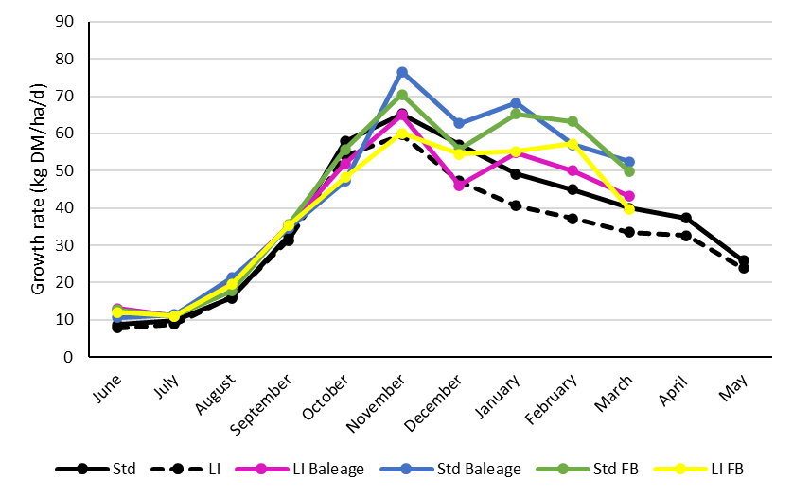 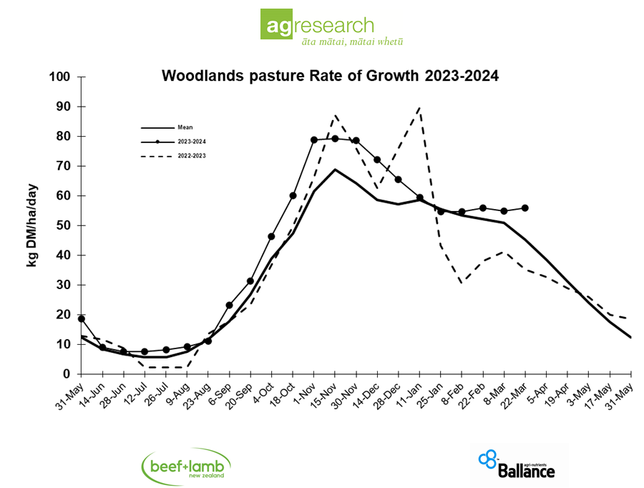

Average monthly pasture growth for the four SDH farmlets and the Woodlands long-term growth rate trial

**Pasture quality results**

**Table 2: Pasture quality from standard and lower impact monitor paddocks for each grazing**



**Table 3: Pasture quality from monitor paddocks with and without plantain for each grazing**

